Chapter 7, Solution 36.

- 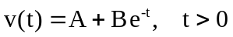
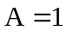, 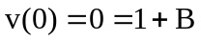 or 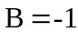
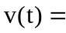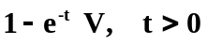

- 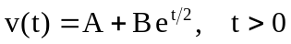
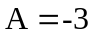, 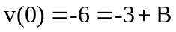 or 